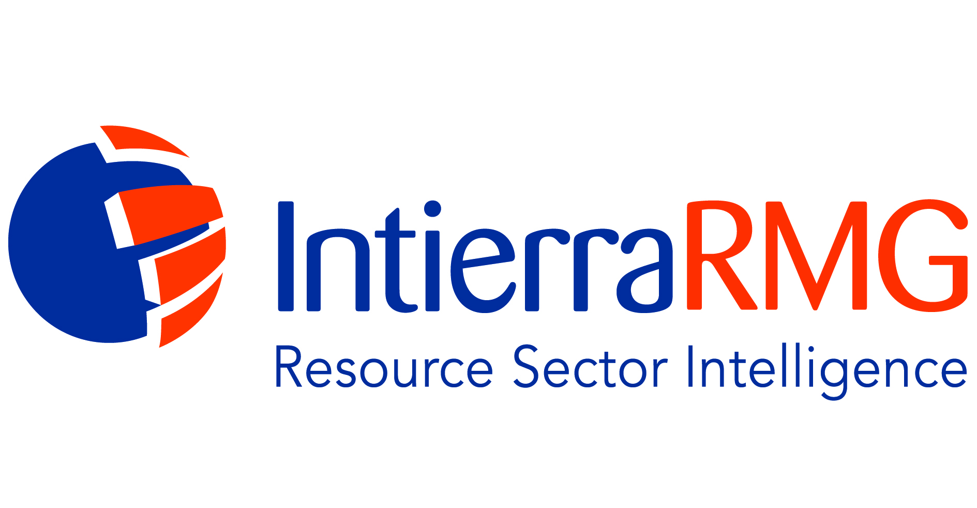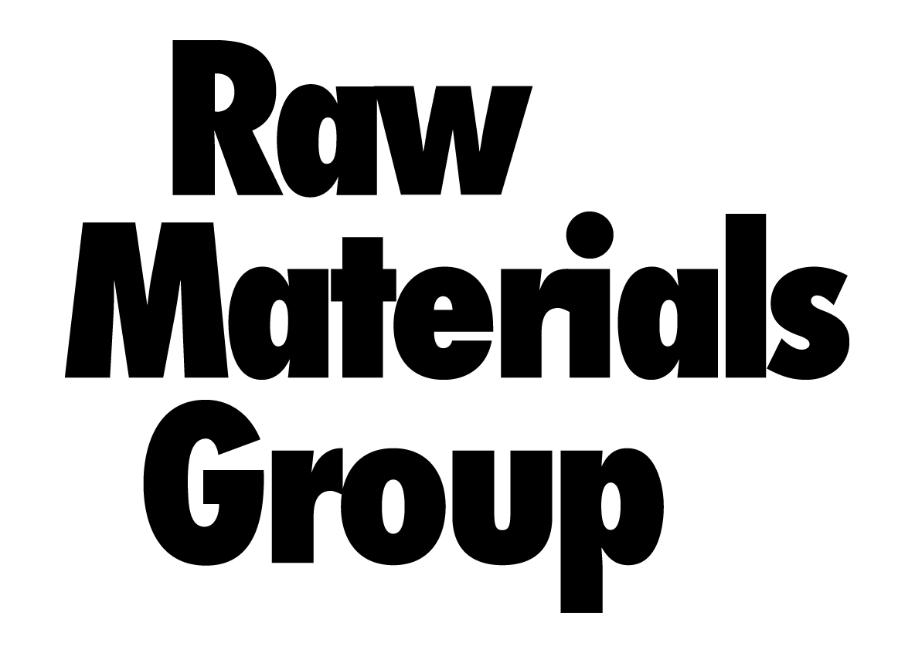
Date: Release time: Immediate

Atlas Copco and Sandvik Light Up Awards Night

For their outstanding achievements above latitude 60º North, Sandvik Mining and Atlas Copco have been presented with the first two 'Northern Lights' industry awards. These inaugural awards were announced last week during the RMG Exploration & Mining Investment Conference in Stockholm.

This prominent industry event, now in its ninth year, was opened by Gunnar Tersman, senior economist of Svenska Handelsbanken AB; one of Sweden's leading banks with over 10,000 employees. In his address, Mr Tersman reminded delegates that the use of resources was a function of economic development, and that supply constraints imply higher real commodity prices in the long term. He was, as a result, bullish for the sector.

Mr Tersman was followed by Boliden's chief executive officer, Lennart Evrell, who provided an update of the company's low-cost, long-life, mines. Like other mining executives that presented at the conference, Mr Evrell stressed the region's excellent geological potential.

Conference attendees also saw presentations from organisations such as Agnico Eagle Mines, Alluvia Mining, Auriant Mining, Beowulf Mining, Dragon Mining, Endomines, Kiruna Iron, Kopparberg Minerals, LKAB, Nickel Mountain, Nordic Iron Ore, Northland Resources, Sotkamo Silver and Talga Resources.

Sandvik Mining won the Northern Lights Equipment Award for Sustainable Development for its eco-efficient Vibrocone comminution system. Launched in September, the Vibrocone equipment has been described as the "next generation of crushing technology." The award was presented during a dinner at Stockholm's Operakällaren by IntierraRMG's editorial director Chris Hinde, and accepted by the vice president of finance at Sandvik Mining, Gert Sköld. Dr Hinde noted that Vibrocone enables energy savings of up to 30%, which is important for the environment.

The Northern Lights Equipment Award for Innovation, which acknowledges the design or technique which has most improved working conditions in the hostile operating environment above 60ºN, was secured by Atlas Copco for Secoroc EDGE; the world's first continuous-monitoring system for exploration drillers. Developed in partnership with Stockholm-based SPC Technology AB, the equipment acts as a new 'eye' for deep-hole drillers. The award was accepted from Dr Hinde by the vice president of research and development at Atlas Copco Secoroc, Timothy Plunkett. Dr Hinde commented that EDGE increases drilling efficiency significantly, and represents a "paradigm shift for the industry".

Dr Hinde summarised the event’s influence; “The RMG Exploration & Mining Investment Conference is the key event for any industry player wishing to learn more about the Nordic resources sector. The 2013 conference, our 10th anniversary, is already shaping up to be the most informative, innovative and exciting conference of the year.”

*** ENDS ***

IntierraRMG delivers respected market and project reports for suppliers, material flows analysis, mineral economics policy and unrivalled consulting expertise. Our databases and sector-specific modules offer unique insights into lease ownership, company evaluations, M&A, risk management, due diligence, competitor intelligence and project pipeline evaluation.

Media Contact: Kelly Chan – Marketing Manager
Phone: +61 8921 46305 or Email: kellyc@intierraRMG.com
Visit: www.intierraRMG.com

